7COM1079-0901-2025 - Team Research and Development Project

Final report title: Is there a difference in the median student academic score (Cumulative Grade Point Average (CGPA)) between depressed and non-depressed students in India?

Group ID: A136

Dataset number: ds002

Prepared by: Aroosha Rasheed [24105689],
Abdulrasheed Ibrahim [24158550],
Sayan Sen [24146068],
Nitika Chopra [24165303],
Vanajakshi Gottapu [24154707]

University of Hertfordshire
Hatfield, 2025

Table of Contents

1. Introduction 3
1.1. Problem statement and Research Motivation (100 words) 3
1.2. The data set (75 words) 3
The dataset used in this research is publicly accessible and titled “Student Depression Dataset” from Kaggle (Adil Shamim, 2025). It contains 27,901 records and 18 columns, where each row represents an Indian university student along with their corresponding depression status. The dataset includes various student-related attributes such as ID, gender, age, academic pressure level, CGPA, sleep duration, and several other behavioral and lifestyle factors. 3
The key variables used in this analysis are CGPA and Depression. 3
1.3. Research question (50 words). 3
“Is there a difference in the median student academic score (Cumulative Grade Point Average (CGPA)) between depressed and non-depressed university students in India?” 3
CGPA is considered the dependent variable (interval data type), and depression status is considered the independent variable (nominal data type). 3
1.4. Null hypothesis and alternative hypothesis (H0/H1) (100 words) 3
2. Background research 4
2.1. Research papers (at least 3 relevant to your topic / DS) (200 words) 4
2.2. Why RQ is of interest (research gap and future directions according to the literature) (100 words) 4
3. Visualisation 5
3.1. Appropriate graphs for the RQ output of an R script (not a screenshot) (50 words) 5
3.2. Additional information relating to understanding the data (optional) (50 words) 6
Assumptions made: 6
Rows where CGPA = 0 were considered as outliers and removed because such values are not realistic academic scores and likely result from missing, miscoded, or incomplete data entries. Including them would distort the distribution and artificially lower the median. Removing these ensures a more accurate comparison between the student groups. 6
3.3. Useful information for the data understanding (50 words) 6
4. Analysis 7
4.1. Statistical test used to test the hypotheses and output (75 words) 7
4.2. The null hypothesis is REJECTED based on the p-value (100 words) 7
5. Evaluation – group’s experience at 7COM1079 8
5.1. What went well (75 words) 8
The project progressed effectively, as the team collaborated well from the beginning. During the planning and analysis phases, clearly assigned roles ensured smooth workflows. We successfully used R to create visualisations and run the statistical test, which produced a statistically significant result. Communication remained strong through regular meetings, supporting steady progress in data cleaning, analysis, and the integration of findings into the final report. 8
5.2. Points for improvement (75 words) 8
A key challenge was the initial interpretation of our counterintuitive result (depressed students showing higher CGPA). More time could have been allocated early to explore potential confounding variables (e.g., academic pressure influencing both performance and depression) and related research literature. Additionally, drafting report sections in a shared document earlier in the workflow, rather than later in the project timeline, would have supported more thorough peer review and improved overall workflow. 8
5.3. Group’s time management (50 words) 8
5.4. Project’s overall judgement (50 words) 8
5.6. Comment on the GitHub log output (50 words) 9
The complete GitHub commit history can be viewed in Appendix B, which shows that version control was used actively and collaboratively throughout the project. The history reflects a clear progression from project setup through analysis to final reporting.
Commit Message: [Update filters to omit students with 0 GGPA] [Commit d909cc5]
This was an important step in preparing the data that made sure our dataset was complete and accurate by removing incomplete information and outliers where CGPA = 0, which made sure that any future analysis would be based on clean data. 9
6. Conclusions 10
6.1. Results explained (75 words) 10
6.2. Interpretation of the results (75 words) 10
6.3. Reasons and/or implications for future work, limitations of your study (50 words) 10
Our study is limited by the dataset’s binary depression variable, with no information on symptom severity or validated screening method. Future work should combine academic performance with measures such as DASS-21 or CES-D and coping assessments, as used by Deb et al. (2016) and Sawhney, Kunen and Gupta (2020), to clarify underlying mechanisms. 10
7. Reference List 10
8. Appendices 11

1. Introduction

Problem statement and Research Motivation (100 words)
Depression is prevalent among Indian university students and is associated with lower academic performance. Yet, existing research provides limited large-scale evidence comparing academic scores between depressed and non-depressed students (Deb et al., 2016). This creates an unresolved question about whether measurable differences in median CGPA exist between these groups. Addressing this gap clarifies how depression corresponds to academic outcomes in a broad student population. This study, therefore, examines whether median CGPA differs between depressed and non-depressed university students in India, using 27,861 cleaned observations (non-missing CGPA and depression; CGPA ≠ 0) and a Wilcoxon rank-sum median comparison.

The data set (75 words)

The dataset used in this research is publicly accessible and titled “Student Depression Dataset” from Kaggle (Adil Shamim, 2025). It contains 27,901 records and 18 columns, where each row represents an Indian university student along with their corresponding depression status. The dataset includes various student-related attributes such as ID, gender, age, academic pressure level, CGPA, sleep duration, and several other behavioral and lifestyle factors.

The key variables used in this analysis are CGPA and Depression.

Research question (50 words).

“Is there a difference in the median student academic score (Cumulative Grade Point Average (CGPA)) between depressed and non-depressed university students in India?”

CGPA is considered the dependent variable (interval data type), and depression status is considered the independent variable (nominal data type).

Null hypothesis and alternative hypothesis (H0/H1) (100 words)
Null Hypothesis (H0): There is no difference in the median student academic score (Cumulative Grade Point Average (CGPA)) among depressed and non-depressed university students in India. ​

Alternative Hypothesis (H1): There is a difference in the median student academic score (Cumulative Grade Point Average (CGPA)) among depressed and non-depressed university students in India.

Background research

Research papers (at least 3 relevant to your topic / DS) (200 words)
Deb et al. (2016) conducted a cross-sectional study of 717 Indian university students to assess the prevalence of depression and related factors. Nearly half of the participants reported moderate to severe depressive symptoms, and depression was significantly associated with students’ perceptions of their academic environment, living arrangements, and personal stressors. However, no direct median-based comparison of CGPA between depressed and non-depressed students was reported. Similarly, Tripathi et al. (2022) evaluated depression, anxiety, and stress among 473 healthcare students using the DASS-21 scale. Their study found substantial psychological distress and observed that higher CGPA was associated with greater levels of DAS, which the authors attributed to competitive academic demands within healthcare programmes. Nevertheless, the study did not provide a direct median-based comparison of CGPA between depressed and non-depressed students, limiting its applicability to analyses specifically focused on academic score differences. In a broader perspective, Awadalla et al. (2024) systematically reviewed 10 studies involving 14,695 students and found consistent evidence that depressive symptoms are negatively associated with academic outcomes. Most studies reported lower GPA or reduced academic performance among students with higher depressive symptom scores, and the review concluded that depression is a significant predictor of diminished academic achievement across diverse contexts.

Why RQ is of interest (research gap and future directions according to the literature) (100 words)
Although previous studies have examined the relationship between depressive symptoms and academic performance among Indian university students, most focus on mean GPA or cross-sectional analyses without comparing median CGPA between depressed and non-depressed students. Findings are inconsistent: some studies report lower academic performance among students with depression, while others observe higher-performing students experiencing greater psychological distress. This gap highlights the need to examine median CGPA differences specifically, providing a more accurate assessment when data are not normally distributed. Investigating this relationship in the Indian context can inform university mental health strategies and guide future research on depression’s impact on academic outcomes.

Visualisation

Appropriate graphs for the RQ output of an R script (not a screenshot) (50 words)
A boxplot was created to compare the median CGPA of depressed and non-depressed Indian university students, addressing the research question. A histogram was used to assess the overall CGPA distribution, while a pie chart illustrated the percentage of students in each depression group.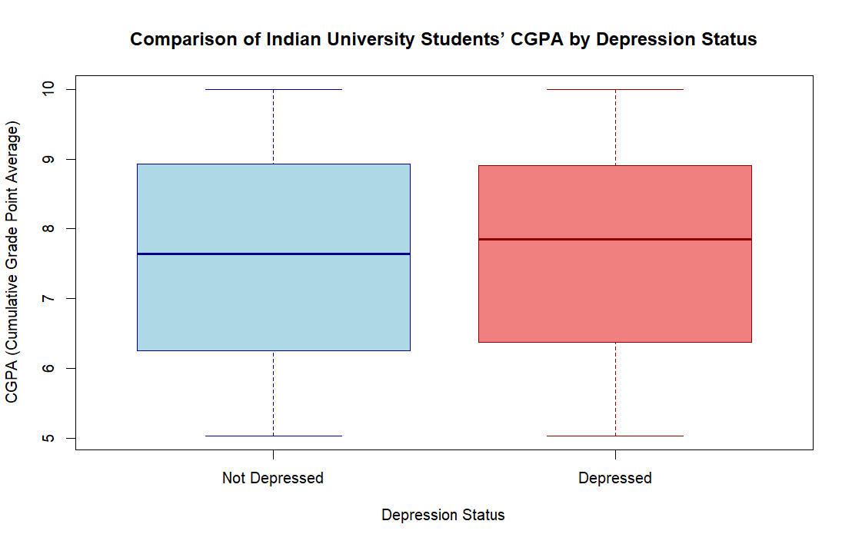
Figure 1: Boxplot comparing the median CGPA of depressed and non-depressed Indian university students.

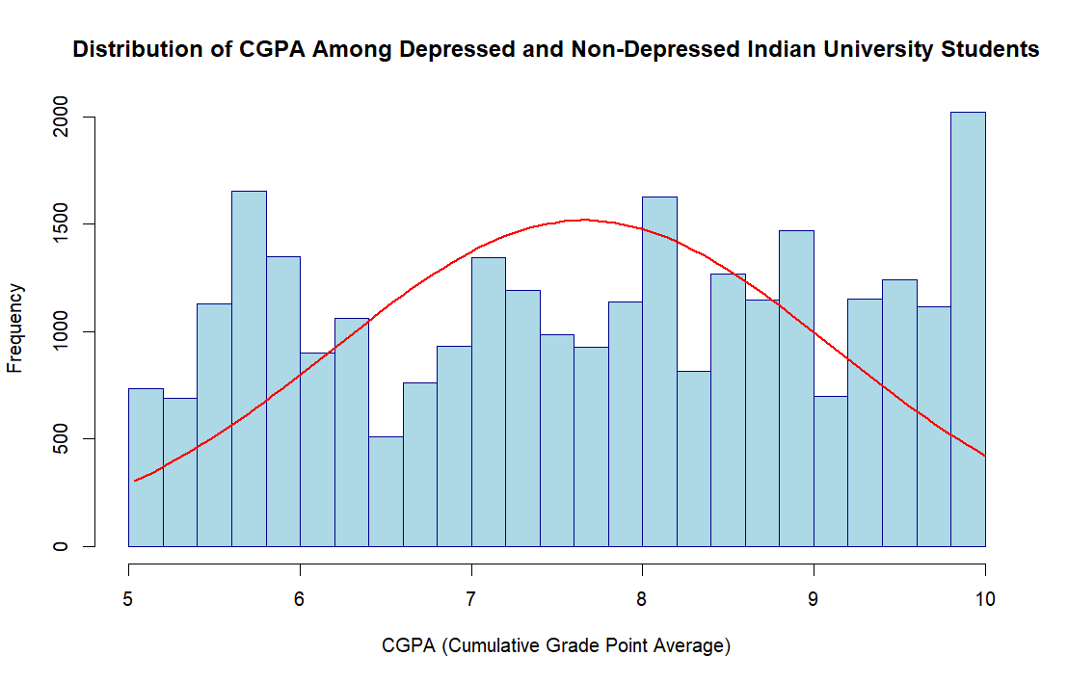
Figure 2: Histogram showing the overall CGPA distribution of Indian university students

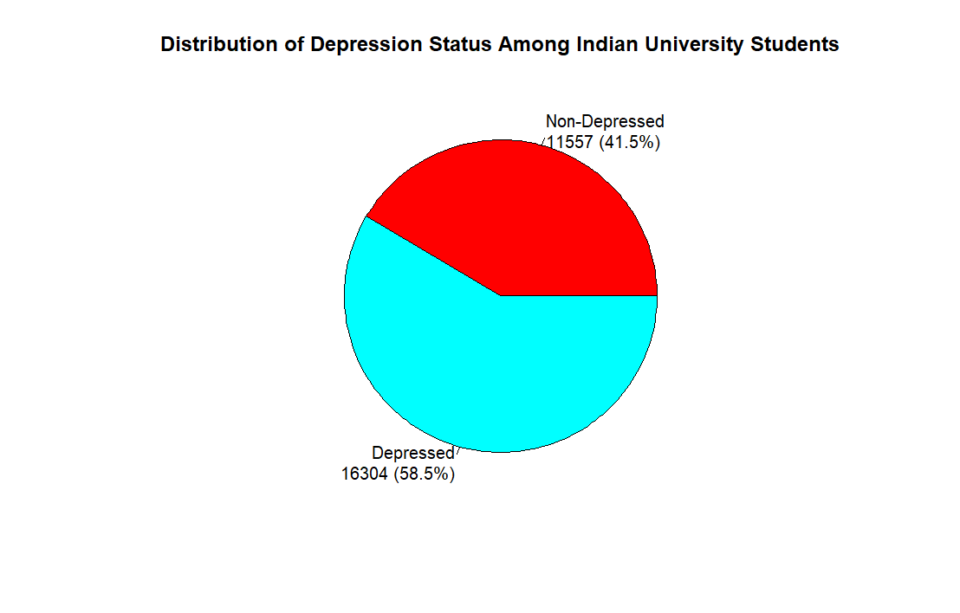
Figure 3: Pie chart illustrating the percentage of students in each depression group

Additional information relating to understanding the data (optional) (50 words)

Assumptions made:

Rows where CGPA = 0 were considered as outliers and removed because such values are not realistic academic scores and likely result from missing, miscoded, or incomplete data entries. Including them would distort the distribution and artificially lower the median. Removing these ensures a more accurate comparison between the student groups.

Useful information for the data understanding (50 words)
The boxplot indicates that students with depression have a slightly higher median CGPA, with both groups displaying similar spreads and overlapping ranges. The histogram shows a multi-modal CGPA distribution rather than a normal one. The pie chart shows an imbalanced sample, with the depressed group exceeding the non-depressed group by about 17%.

Analysis

Statistical test used to test the hypotheses and output (75 words)
The Wilcoxon Rank-Sum test (Mann–Whitney U) was selected for this analysis. This non-parametric test is appropriate because the research question examines differences in central tendency between two independent groups. A histogram with a normal curve overlay shows that CGPA scores are non-normal and multimodal. Parametric tests depend on normality; given our multimodal CGPA distribution, we therefore used the Wilcoxon test. Data cleaning excluded CGPA values of zero and restricted the dataset to student records only.

The null hypothesis is REJECTED based on the p-value (100 words)
The Wilcoxon Rank-Sum test yielded a p-value of 0.0003097, which is less than the significance level of α = 0.05. Consequently, we reject the null hypothesis (H₀: There is no difference in median CGPA between depressed and non-depressed university students in India) in favour of the alternative hypothesis (H₁: There is a difference in median CGPA between depressed and non-depressed university students in India). The descriptive statistics show that depressed students demonstrated a higher median CGPA of 7.85 compared to 7.64 for non-depressed students. Therefore, the findings indicate that a difference exists, with depressed students in India performing slightly better academically than non-depressed students.

Evaluation – group’s experience at 7COM1079

What went well (75 words)

The project progressed effectively, as the team collaborated well from the beginning. During the planning and analysis phases, clearly assigned roles ensured smooth workflows. We successfully used R to create visualisations and run the statistical test, which produced a statistically significant result. Communication remained strong through regular meetings, supporting steady progress in data cleaning, analysis, and the integration of findings into the final report.

Points for improvement (75 words)

A key challenge was the initial interpretation of our counterintuitive result (depressed students showing higher CGPA). More time could have been allocated early to explore potential confounding variables (e.g., academic pressure influencing both performance and depression) and related research literature. Additionally, drafting report sections in a shared document earlier in the workflow, rather than later in the project timeline, would have supported more thorough peer review and improved overall workflow.

Group’s time management (50 words)
Overall, time management was strong. We set a clear project timeline with precise weekly goals that helped track progress in data cleaning, analysis, and report writing. Regular meetings kept the team aligned, preventing a last-minute rush and ensuring each project phase was completed on time.

Project’s overall judgement (50 words)
The project was a complete success. We addressed the research question using appropriate methodologies, producing significant and insightful results. The entire process—from data cleaning and hypothesis formulation to visualisation, analysis, and final conclusions—was thoroughly documented. This project experience strengthened our data analysis abilities and enhanced our collaborative research skills.

  - Note any changes to the group since the original allocation, if applicable. Add new or amended GitHub IDs for new members (75 words, write only if it applies to your group arrangements)
No changes were made to the original group allocation.

Comment on the GitHub log output (50 words)

The complete GitHub commit history can be viewed in Appendix B, which shows that version control was used actively and collaboratively throughout the project. The history reflects a clear progression from project setup through analysis to final reporting.
Commit Message: [Update filters to omit students with 0 GGPA] [Commit d909cc5]
This was an important step in preparing the data that made sure our dataset was complete and accurate by removing incomplete information and outliers where CGPA = 0, which made sure that any future analysis would be based on clean data.
Commit Message: [Added boxplot for CGPA of depressed and non-depressed students] [Commit 551ab8a]
This created the essential visualisation that made it easy to compare the two groups at first, revealing the surprising trend that guided our interpretation of the statistical results.
Commit Message: [Add Wilcoxon test back] [Commit 0a77a04]
This commit executed the main statistical test for our hypothesis, giving us the clear quantitative proof (p < 0.05), which was required to reject the null hypothesis and answer our research question.

Conclusions

Results explained (75 words)
As highlighted in our report, many previous studies found that depressive symptoms are associated with lower academic performance. However, our results contrast with this trend. Depressed Indian university students in our dataset demonstrated a higher median CGPA (7.85) than non-depressed students (7.64), a statistically significant difference of 0.21 grade points. This unexpected finding suggests that the relationship between depression and academic achievement may be more complex than commonly reported and influenced by additional contextual factors.

Interpretation of the results (75 words)
Our findings suggest that depressed Indian university students in this dataset achieved slightly higher median CGPA scores than non-depressed students, contrasting with much of the existing literature. One possible explanation, supported by Tripathi et al. (2022), is that higher-performing students may experience intense academic pressure or perfectionistic tendencies that elevate depressive symptoms while maintaining strong grades. This result highlights the complex relationship between psychological distress and achievement and suggests that high academic performance does not necessarily indicate good mental health.

Reasons and/or implications for future work, limitations of your study (50 words)

Our study is limited by the dataset’s binary depression variable, with no information on symptom severity or validated screening method. Future work should combine academic performance with measures such as DASS-21 or CES-D and coping assessments, as used by Deb et al. (2016) and Sawhney, Kunen and Gupta (2020), to clarify underlying mechanisms.

Reference List

Shamim, A. (2025) Student Depression Dataset. Kaggle. Available at: https://www.kaggle.com/datasets/adilshamim8/student-depression-dataset/data (Accessed: 9 December 2025).
Deb, S., Banu, P.R., Thomas, S., Vardhan, R.V., Rao, P.T. and Khawaja, N. (2016) ‘Depression among Indian university students and its association with perceived university academic environment, living arrangements and personal issues’, Asian Journal of Psychiatry, 23, pp. 108–117. doi: 10.1016/j.ajp.2016.07.010.
Tripathi, R., Alqahtani, S.S., Meraya, A.M., Makeen, H.A., Tripathi, P. and Pancholi, S.S. (2022) ‘Evaluation of depression, anxiety, and stress among university healthcare students’, Journal of Pharmaceutical Sciences and Research, 14(8), pp. 1234–1242. Available at: https://www.japsonline.com/admin/php/uploads/3747_pdf.pdf (Accessed: 11 December 2025).
Awadalla, S., Davies, E.B. and Glazebrook, C. (2024) ‘The impact of depressive and anxiety symptoms on academic achievement among undergraduate university students: A systematic review’, OBM Neurobiology, 8(4), pp. 1–15. Available at: https://www.lidsen.com/journals/neurobiology/neurobiology-08-04-261 (Accessed: 11 December 2025).
Sawhney, M., Kunen, S. and Gupta, A. (2020) ‘Depressive symptoms and coping strategies among Indian university students’, Psychological Reports, 123(2), pp. 266–280. doi: 10.1177/0033294118820511.

Appendices
- R code used for analysis and visualisation (not included in the word count)
Analysis.R code with the appropriate statistics to test the hypotheses.

# R Code for Data Cleaning, Analysis & Visualisation

library(tidyverse)
data <- read_csv("dataset.csv")

# Filter students only??
data_students <- data %>%
filter(Profession == "Student")

print("Total observations in dataset:")
print(nrow(data))
print("Student observations:")
print(nrow(data_students))

#find number of students with CGPA = 0
data_students %>%
filter(CGPA == 0) %>%
nrow()

# Clean data; Remove any rows with missing CGPA or Depression values, and remove CGPA of 0
data_clean <- data_students %>% filter(!is.na(CGPA) & !is.na(Depression) & CGPA != 0)

print("Clean observations (no missing data):")
print(nrow(data_clean))

#check for the total number of rows removed from the dataset after data cleaning and filterng
nrow(data) # original
nrow(data_clean) # cleaned

# Overall CGPA statistics
print("Overall CGPA Summary:")
summary(data_clean$CGPA)

# CGPA by depression status
#adding Q1, Q2, IQR and add the title to the table
print("CGPA by Depression Status (descriptive statistics)")
cgpa_by_depression <- data_clean %>%
group_by(Depression) %>%
summarise(
n = n(),
Mean = mean(CGPA),
SD = sd(CGPA),
Median = median(CGPA),
Q1 = quantile(CGPA, 0.25),
Q3 = quantile(CGPA, 0.75),
IQR = IQR(CGPA),
Min = min(CGPA),
Max = max(CGPA)
)
print(cgpa_by_depression)

# Check distribution (normality assessment)
# Separate CGPA by depression status using base R bracket notation
cgpa_not_depressed <- data_clean$CGPA[data_clean$Depression == 0]
cgpa_depressed <- data_clean$CGPA[data_clean$Depression == 1]
cgpa_overall <- data_clean$CGPA

# Overall CGPA Histogram (both depressed and non-depressed students) - bell curve overlay with frequency
print("Histogram of Cumulative Grade Point Average (CGPA) of Depressed and Non-depressed University students in India")
h <- hist(cgpa_overall,
main = "Distribution of CGPA Among Depressed and Non-Depressed Indian University Students",
xlab = "CGPA (Cumulative Grade Point Average)",
ylab = "Frequency",
col = "lightblue",
border = "darkblue",
breaks = 20,
freq = TRUE)

mean_val <- mean(cgpa_overall, na.rm = TRUE)
sd_val <- sd(cgpa_overall, na.rm = TRUE)

# Scale the bell curve to match frequency
x <- seq(min(cgpa_overall), max(cgpa_overall), length = 100)
y <- dnorm(x, mean_val, sd_val) * length(cgpa_overall) * diff(h$breaks)[1]

# Overlay curve
lines(x, y, col = "red", lwd = 2)

# Boxplot for the CGPA of depressed and non-depressed students created
# depressed students perform slightly better academically
print("Boxplot of Cumulative Grade Point Average (CGPA) of Depressed and Non-depressed University students in India")
boxplot(CGPA ~ Depression,
data = data_clean,
main = "Comparison of Indian University Students’ CGPA by Depression Status",
xlab = "Depression Status",
ylab = "CGPA (Cumulative Grade Point Average)",
names = c("Not Depressed", "Depressed"),
col = c("lightblue", "lightcoral"),
border = c("darkblue", "darkred"))

#create a pie chart for the depressed and non-depressed students with percentages
#pie chart with proper labels
# Count depression status
counts <- table(data_clean$Depression)

# Labels
labels <- c("Non-Depressed", "Depressed")

# Calculate percentages
percentages <- round(100 * counts / sum(counts), 1) # rounded to 1 decimal

# Combine labels with counts and percentages
labels_with_pct <- paste0(labels, "\n", counts, " (", percentages, "%)")

# Create pie chart
pie(
counts,
main = "Distribution of Depression Status Among Indian University Students",
col = rainbow(length(counts)),
labels = labels_with_pct
)

# Statistical Tests
# Wilcoxon Rank-Sum Test
print("Wilcoxon Rank-Sum Test:")
wilcox_test_result <- wilcox.test(CGPA ~ Depression, data = data_clean)
print(wilcox_test_result)

- GitHub log output.

The Git log was generated using the following command in the terminal.
“git log --oneline --graph --decorate --all > git_log.txt”

* 4e38ba1 (HEAD -> main, origin/main, origin/HEAD) Update R code in report file
* 48360ba update git log and add git log file because it's too long
* 0f903e0 Updated conclusion* 9858d40 Updated conclusion
* 546b64d Added conclusion
* 97e4055 Added RQ and Hypothesis to Report
* abe18f1 Added other parts in visualizations
* 8ce002b Added other parts in visualizations
* bc0640b do some changes in script file
* 46f54f3 generate git output for report
* e1c2d33 Adding git output
* 69b1fcc Working on Report
* b6242d6 Added Script File for Reporting with commenting
* 52cc5d4 Merge pull request -temp docs
|\
| * 6b4052a (origin/temp-docs) Removed temporary word document
| * 4dda726 Removed temporary ppt file
* | ad7c217 References added to report
* | f735d54 Made changes to report
|/
* 621c207 Added research gap and future direction v1
* f71348f Added explanation and captions to visualizations in report
* 5619a76 Added visualizations to report
* ce75675 Made changes to plot labels for clarity and added them to 'plots' folder
* 61b3ec4 Made changes to version 1 of background research summaries in the report
* d5bfc82 Made changes to version 1 of background research summaries in the report
* 29bd300 Added version 1 of background research summaries in the report
* fc678f9 Add reference for Problem statement
* f45abe2 Add Table of Content, Problem Statement and Analysis sections
* 35f51a3 Added latest demo ppt for visualizations and analysis
* b89d84c Added latest demo ppt for visualizations and analysis
* cd4ee54 Resolve merge conflict
|\
| * d984251 Remove T Test
| * 37a15a4 Remove "Class 12" filter on Degree column
| * d226a2e Remove city filters / unique counts.
| * 0a77a04 Add WIlcoxon test back
| * b431fd9 data set file name
* | ece80be Removed filters for city and degree
|/
* 72d1e17 Added total number of rows removed after cleaning and more analysis on data cleaning
* 7cc06bc Changed README
* 7a1c558 Remove wilcoxon
* 282baef Add Boxplot
* 4c23c69 Update histogram plot
* 9b12aa2 Update pie plot dir
* 96ed648 Remove empty lines
* 5afaf26 Added the proper histogram and boxplot to the plot folder
* 04f956a Removed histogram without bell curve overlay
* 33bf24e Changes in Pie chart
* 5f594a8 Remove QQ Plots
* a66c60e Remove Wilcoxon test since our data is now normally distributed
* d909cc5 Update filters to omit students with 0 GGPA
* 7e74772 Add plots to README.md
| * e8a3752 (origin/update-hist) Update RQ in report
| * 0084246 Update hist
|/
* d29f6d2 changed the data cleaning
* cd6ec19 Clean up Degree filtering code
* 870c5db Merge pull request #12 from Abdoulrasheed/updates
|\
| * 7cd0c2b (origin/updates) Added changes to Pie chart
| * 171c1a2 Added changes to pie chart
* | b9eb0fa find unique Degree values again to see whether noisy data still exists and find the total number of unique degree values within the dataset
|\
| * 96c2289 Added changes to CPGA by Depression
* | 21ccf57 find unique Degree values again to see whether noisy data still exists and find the total number of unique degree values within the dataset
|/
* ee65414 changed the data cleaning
* 4fa614b Newly added data cleaning steps and to check for noisy values within the dataset
* b3896e4 Added RQ to README file
* 39147b2 Changed the title and x axis name of the boxplot - more detailed for clarity
* f1eae89 Made changes to the visualizations and analysis demo ppt based on lecturer feedback
* c61b8f6 Changed the title and x axis name of the histogram - more detailed for clarity
* b66e29e Add cover page, team information and research question to report
* 7cc3325 Add files via upload
* 1e3c204 Add QQ plots for normality assessment of CGPA by depression status
* 78cbbeb Merge pull request #11 from Abdoulrasheed/aroosha-visualizations
|\
| * c12c341 (origin/aroosha-visualizations) Add Bell curve overlay for overall CGPA
| * 1de6a09 Add Bell curve overlay for overall CGPA
* | a88a90e Merge pull request #10 from Abdoulrasheed/aroosha-visualizations
|\
| * da62652 Removed histograms for CGPA of separate depressed and non-depressed students (only overall kept)
|/
* b09105b Update Student Depression.R
* 1dea2c1 Merge pull request #9 from Abdoulrasheed/aroosha-visualizations
|\
| * e0e5415 Added some changes to PPT file
|/
* 5114669 Merge pull request #8 from Abdoulrasheed/aroosha-visualizations
|\
| * 92adb1b Added RQ ppt to PPPT and Documentations folder
* | bf82cbe Merge pull request #7 from Abdoulrasheed/aroosha-visualizations
|\
| * bd4def0 Added new folder ppt and documentations
* | 2ec26fb Merge pull request #6 from Abdoulrasheed/aroosha-visualizations
|\
| * e5710b3 Added visualization and analysis ppt
* | ff6df26 Update Phase I tasks to completed status
* | fb3c3cb Add T-test / WilcoxOn
* | 76ee82e Merge pull request #5 from Abdoulrasheed/aroosha-visualizations
|\
| * 551ab8a Added boxplot for CGPA of depressed and non depressed students
* | b25de4e Merge pull request #4 from Abdoulrasheed/aroosha-visualizations
|\
| * 1f2ebbd Added Histogram for CGPA of depressed students and results
* | f43ede6 Merge pull request #3 from Abdoulrasheed/aroosha-visualizations
|\
| * ea85657 Updated visualizations and improvements for CGPA of non depressed students
| * b5ae98a Added Histogram for CGPA of non depressed students and result
* | ec7eb92 Merge pull request #2 from Abdoulrasheed/aroosha-visualizations
|\
| * 1dc6057 Added Histogram for Overall CGPA and result
|/
* 7037856 Separate CGPA by depression status using base R bracket notation is done [Nitika]
* 620775a CGPA by depression status is done [Nitika]
* e336480 Checking the overview of CGPA like minimum, maximum, mean and other basic statistics
* 2582ac9 Number of rows remaining after cleaning data
* d56d0f8 Cleaned the rows with missing values of CGPA and Depression
| * 8ad37f1 (origin/sayan) updated analysis
|/
* bcc6099 Dataset analysis
| * 7aa4353 (origin/Nitika) Update README.md
|/
* 0706ef1 (origin/Vanajakshi) Update README.md
* d9631ae Update README.md
* aa39c99 Update Phase I tasks to completed status
* 5bd1ad3 Add dataset
* a0bb11b

